***Preprocessing***

* ***Without filter***

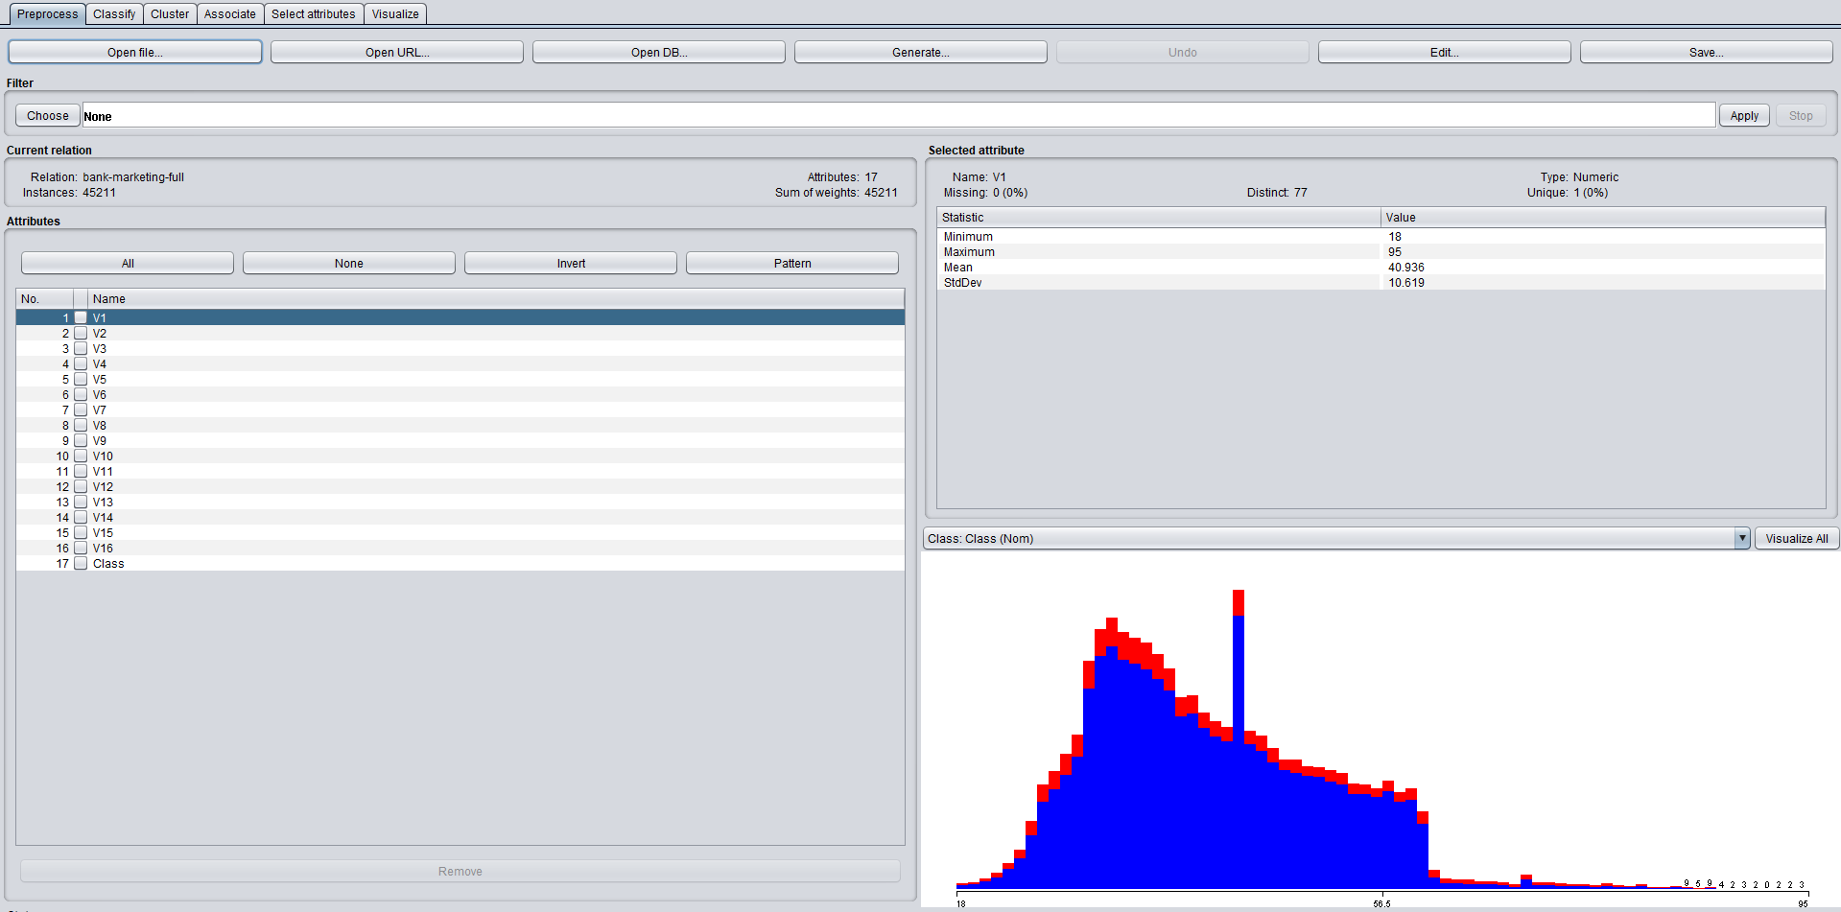

* ***SpreadSubsample***

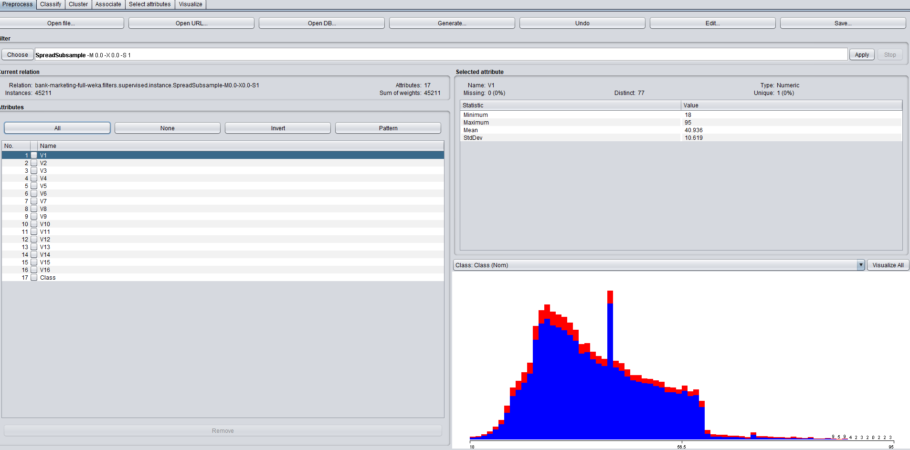

* ***Resample***

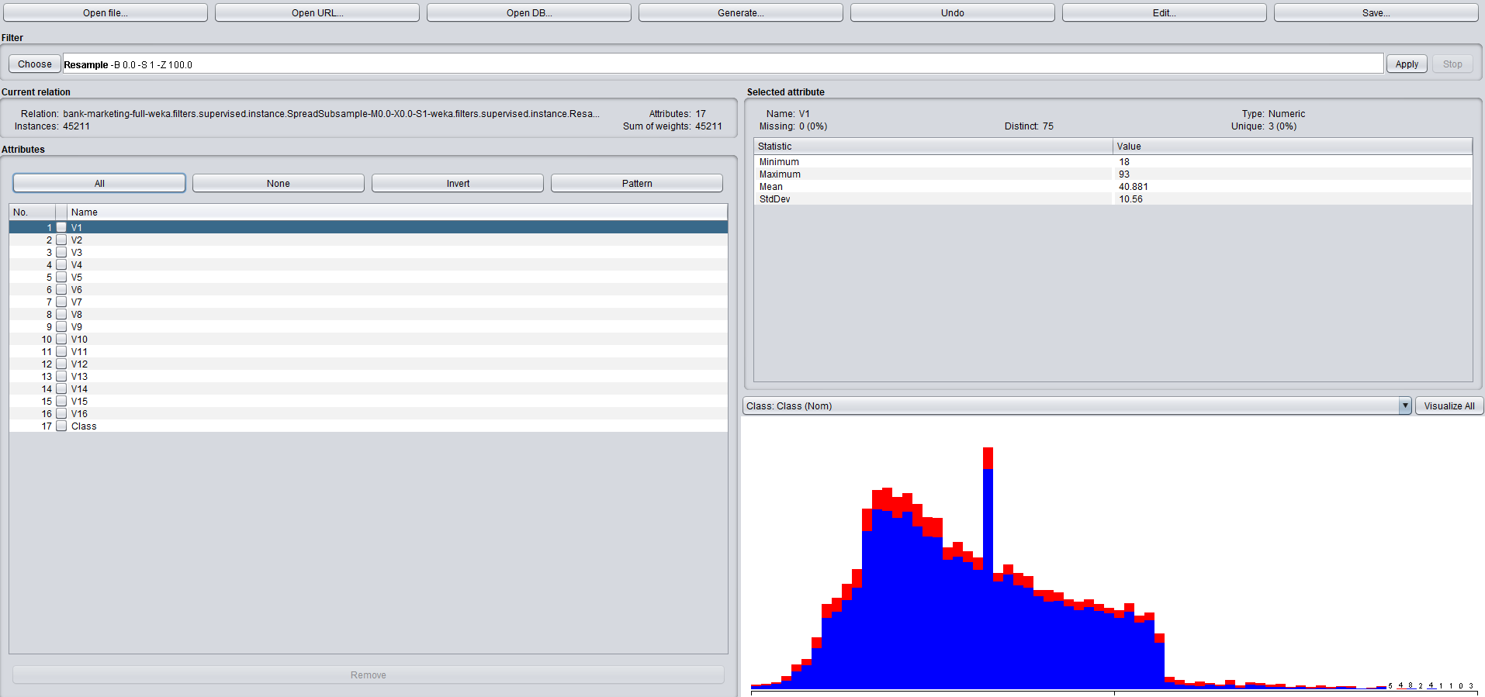

***Train data mining algorithm***

* ***J48***

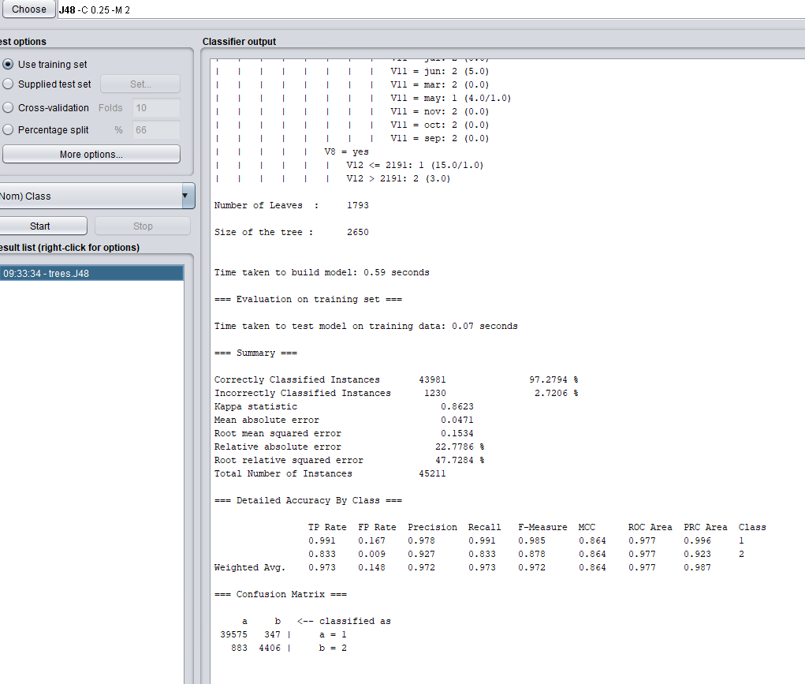

* ***J48 : testing test***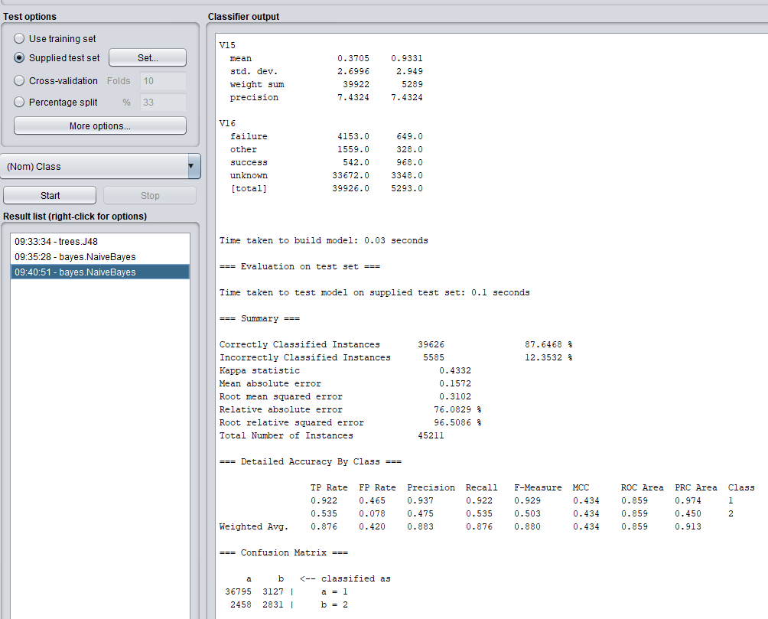
* ***Naïve bayes***

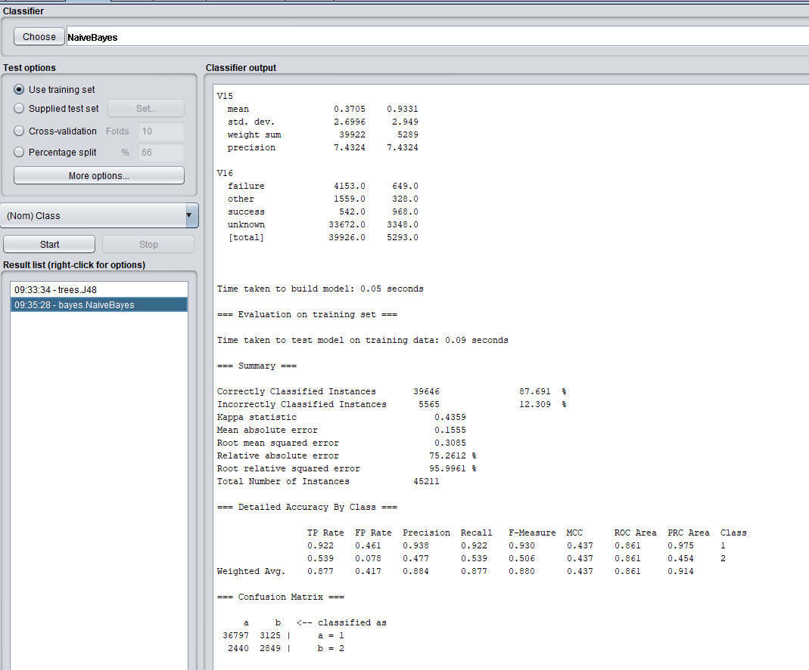

* ***Naïve Bayes : testing set***

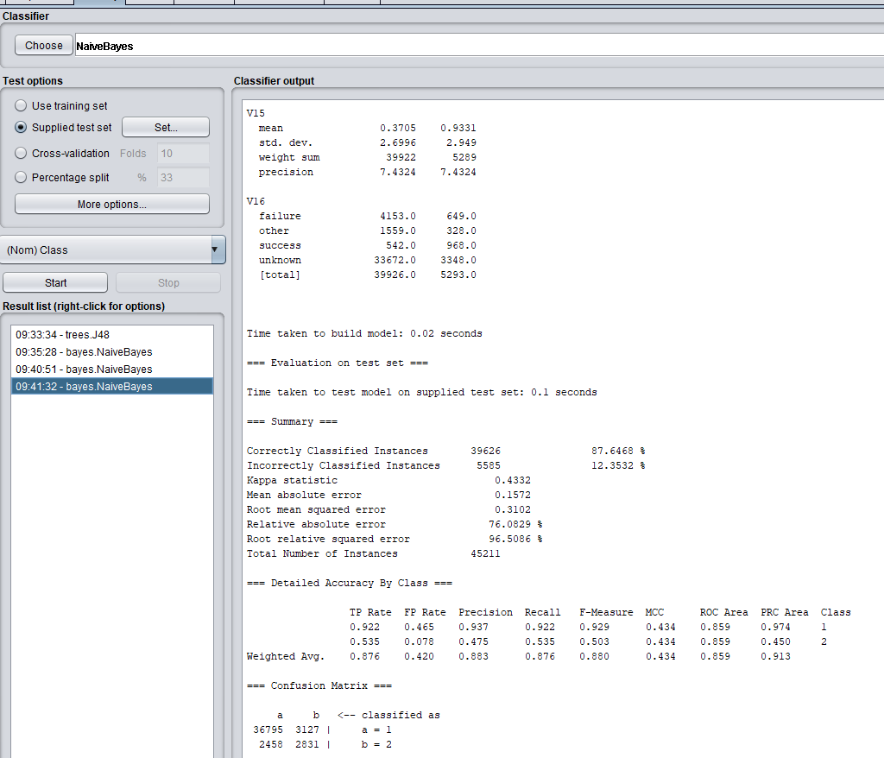

***Evaluation matrix***

* ***J48***

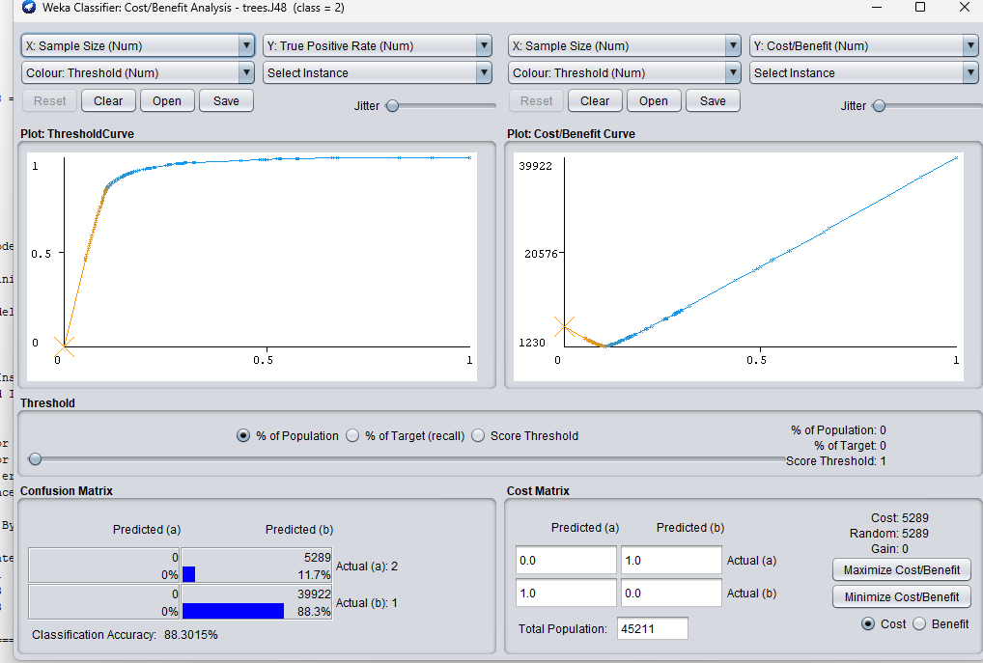

* ***Naïve bayes***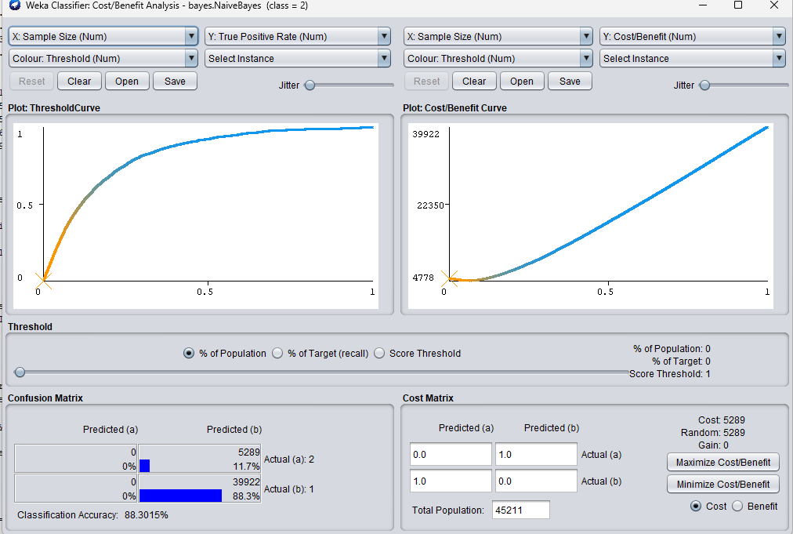

***Naïve Bayes classifier is better***